DBMS Lab: SQL Joins and Transactions

Part A: Create Tables
CREATE TABLE roles(role_id INT PRIMARY KEY, role_name VARCHAR(50));
CREATE TABLE users(user_id INT PRIMARY KEY,name VARCHAR(50),email VARCHAR(50),role_id INT);
CREATE TABLE departments(dept_id INT PRIMARY KEY,dept_name VARCHAR(50));
CREATE TABLE employees(emp_id INT PRIMARY KEY,emp_name VARCHAR(50),dept_id INT,manager_id INT,salary DECIMAL(10,2));
CREATE TABLE customers(customer_id INT PRIMARY KEY,customer_name VARCHAR(50),city VARCHAR(50));
CREATE TABLE orders(order_id INT PRIMARY KEY,customer_id INT,order_date DATE,total_amount DECIMAL(10,2));
CREATE TABLE accounts(account_no INT PRIMARY KEY,holder_name VARCHAR(50),balance DECIMAL(10,2));
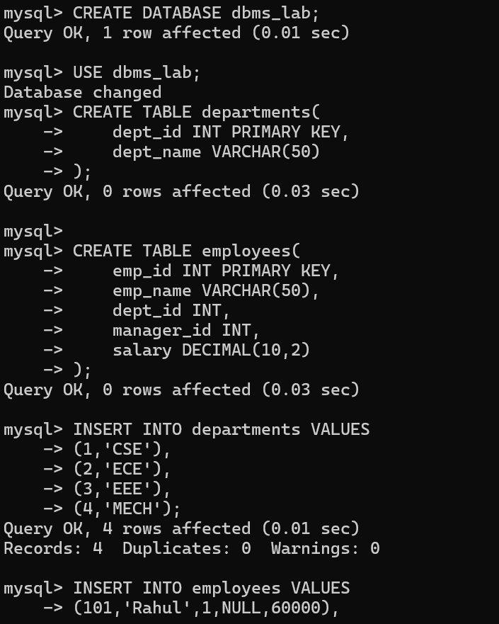
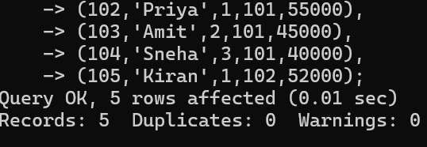
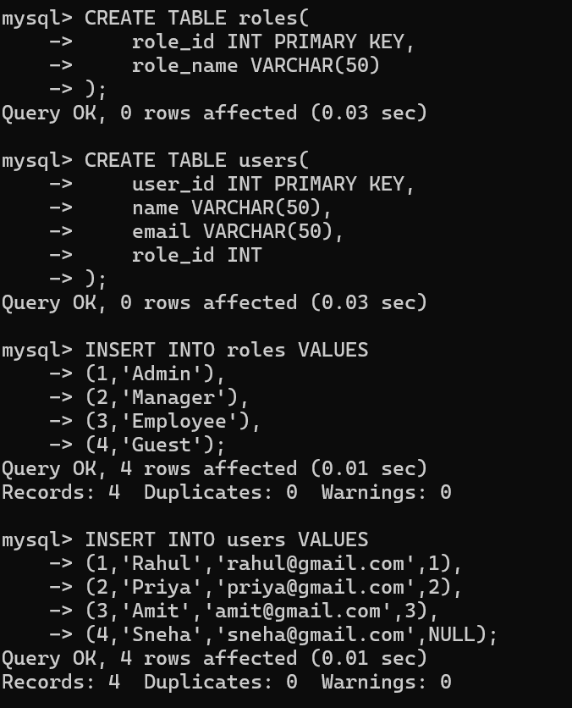

Q1. Display employee names with their department names using INNER JOIN.
SELECT emp_name,dept_name FROM employees e INNER JOIN departments d ON e.dept_id=d.dept_id;
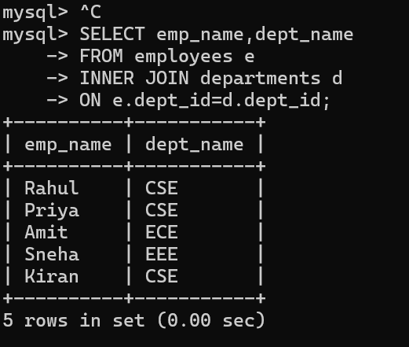

Q2. Display all users with their assigned roles using LEFT JOIN.
SELECT name,email,role_name FROM users u LEFT JOIN roles r ON u.role_id=r.role_id;
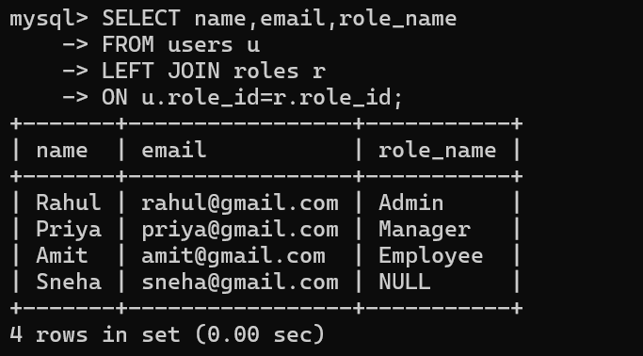

Q3. Display all roles even if no users are assigned using RIGHT JOIN.
SELECT name,role_name FROM users u RIGHT JOIN roles r ON u.role_id=r.role_id;
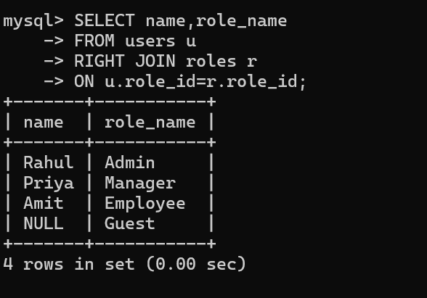

Q4. Simulate FULL OUTER JOIN in MySQL.
SELECT name,email,role_name FROM users u LEFT JOIN roles r ON u.role_id=r.role_id UNION SELECT name,email,role_name FROM users u RIGHT JOIN roles r ON u.role_id=r.role_id;
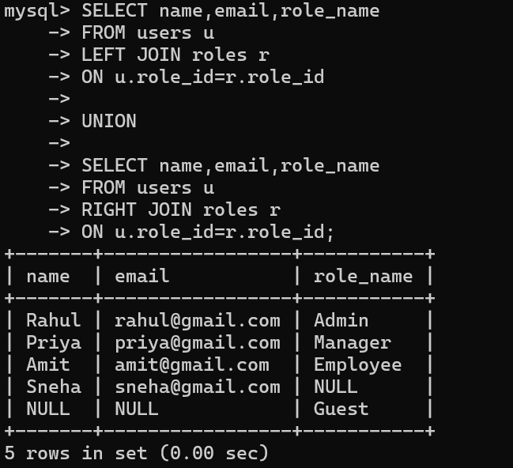

Q5. Display employee and manager names using SELF JOIN.
SELECT e.emp_name Employee,m.emp_name Manager FROM employees e LEFT JOIN employees m ON e.manager_id=m.emp_id;
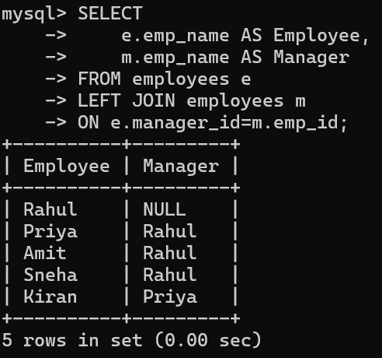

Q6. Display Order ID, Customer Name, City and Total Amount.
SELECT o.order_id,customer_name,city,total_amount FROM customers c JOIN orders o ON c.customer_id=o.customer_id;
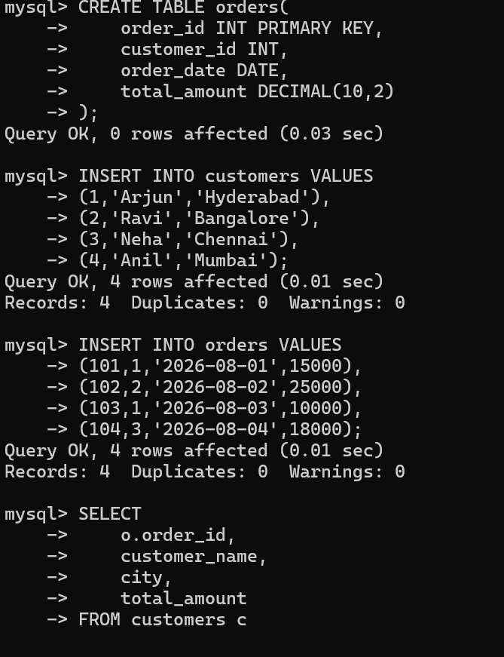
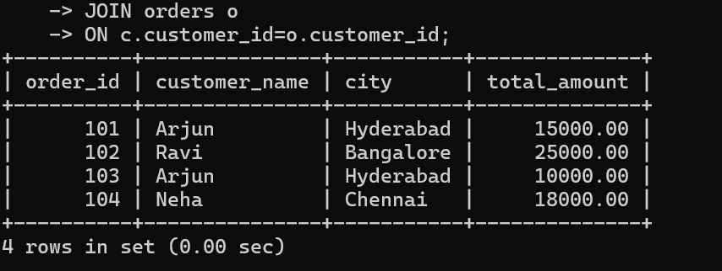

Q7. Find department-wise employee count, average salary and maximum salary.
SELECT dept_name,COUNT(*),AVG(salary),MAX(salary) FROM employees e JOIN departments d ON e.dept_id=d.dept_id GROUP BY dept_name;
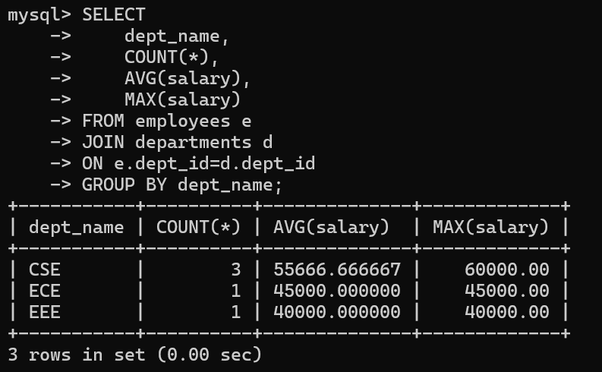

Q8. Display employees earning >50000 in CSE.
SELECT emp_name,salary,dept_name FROM employees e JOIN departments d ON e.dept_id=d.dept_id WHERE salary>50000 AND dept_name='CSE';
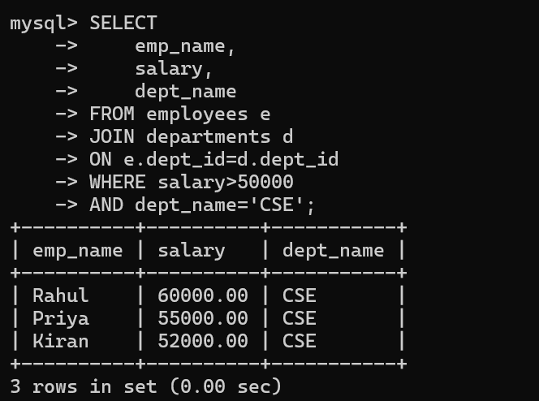

Q9. Display customer-wise total purchase in descending order.
SELECT customer_name,SUM(total_amount) TotalPurchase FROM customers c JOIN orders o ON c.customer_id=o.customer_id GROUP BY customer_name ORDER BY TotalPurchase DESC;
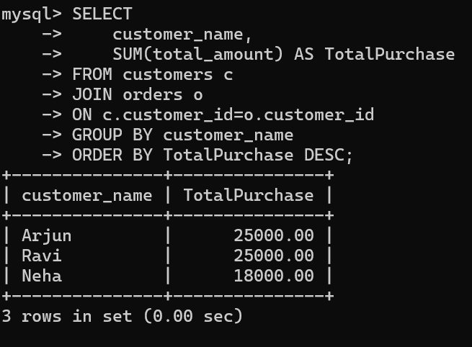

Q10. Create Students, Courses, Faculty, Enrollments and display Student, Course, Faculty using joins.
SELECT student_name,course_name,faculty_name FROM students s JOIN enrollments e ON s.student_id=e.student_id JOIN courses c ON e.course_id=c.course_id JOIN faculty f ON c.faculty_id=f.faculty_id;
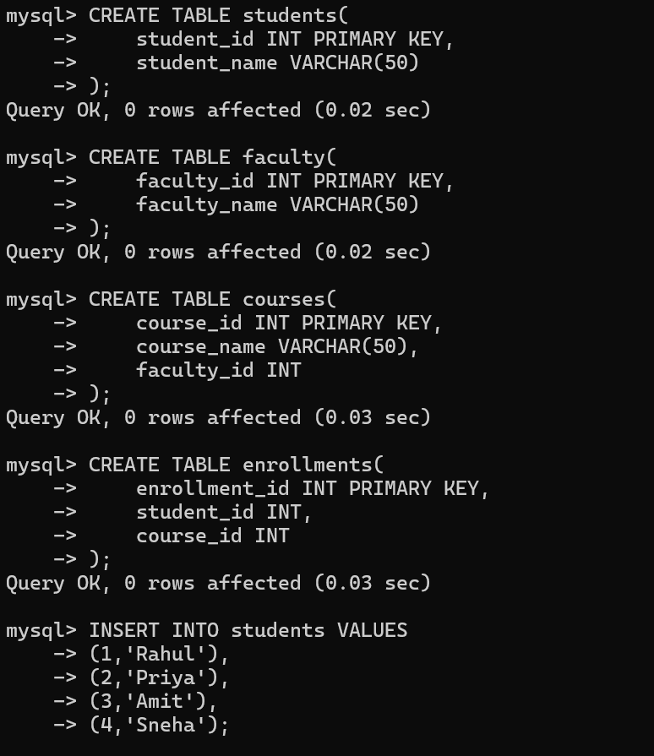
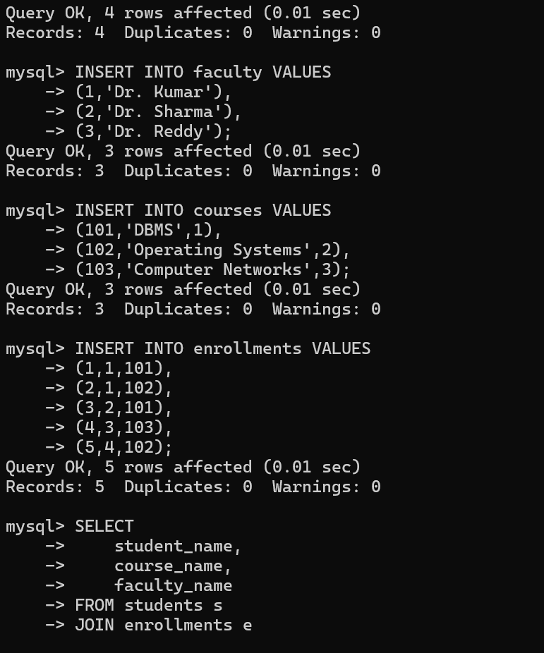
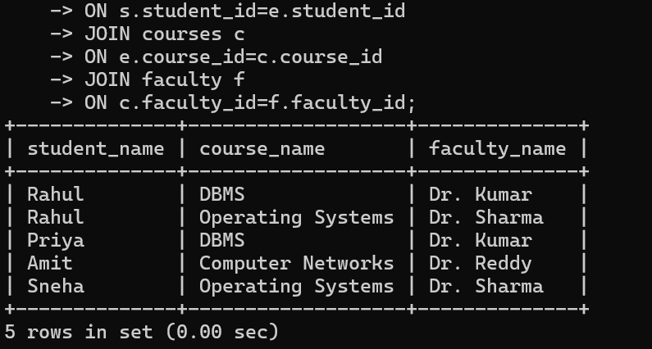

Part B: Transactions

Q11. Insert a new account and COMMIT.
START TRANSACTION; INSERT INTO accounts VALUES(104,'Anil',25000); COMMIT;
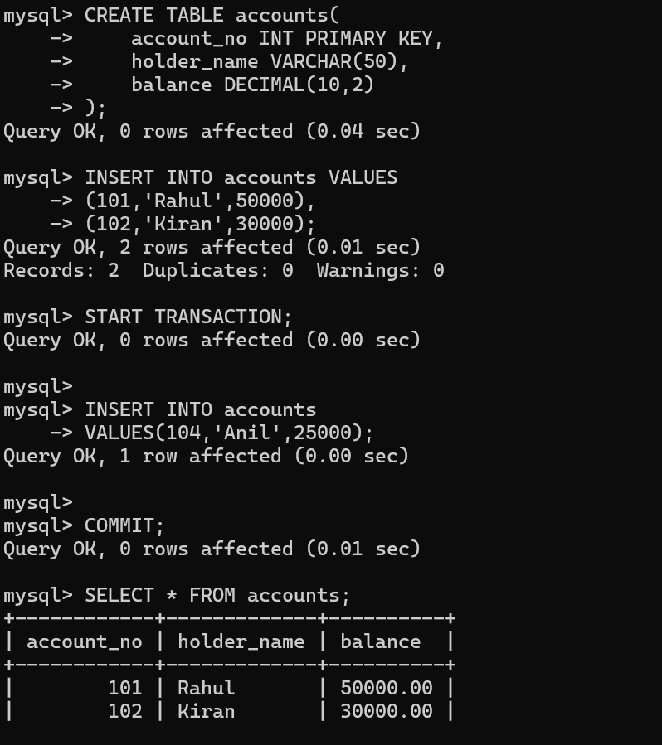
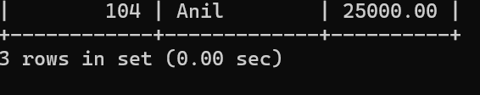

Q12. Insert a record and ROLLBACK.
START TRANSACTION; INSERT INTO accounts VALUES(105,'Ravi',10000); ROLLBACK;
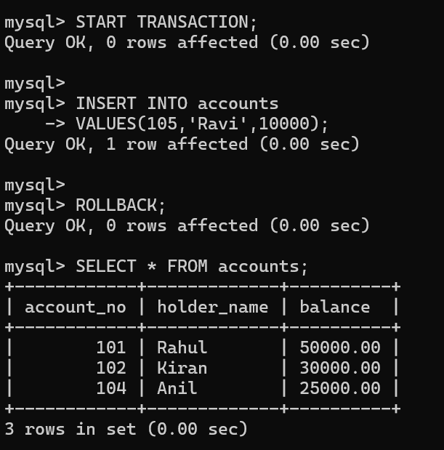

Q13. Transfer ₹5000 from Account 101 to 102.
START TRANSACTION; UPDATE accounts SET balance=balance-5000 WHERE account_no=101; UPDATE accounts SET balance=balance+5000 WHERE account_no=102; COMMIT;
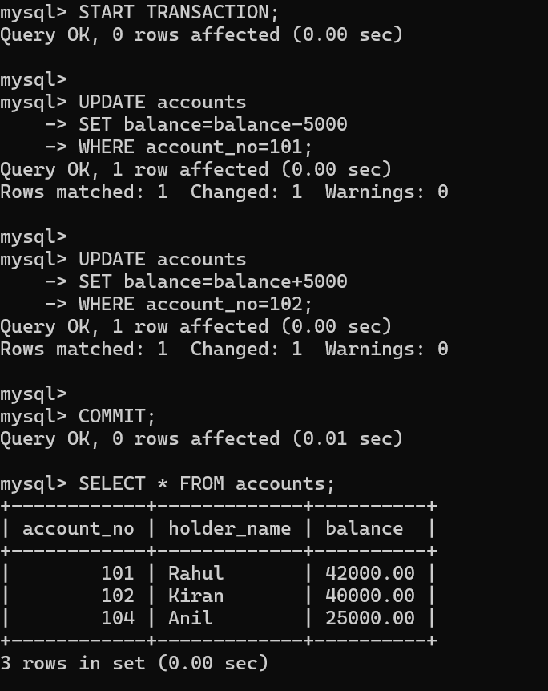

Q14. Simulate failed transaction and rollback.
START TRANSACTION; UPDATE accounts SET balance=balance-3000 WHERE account_no=101; UPDATE accounts SET balance=balance+3000 WHERE account_no=999; ROLLBACK;
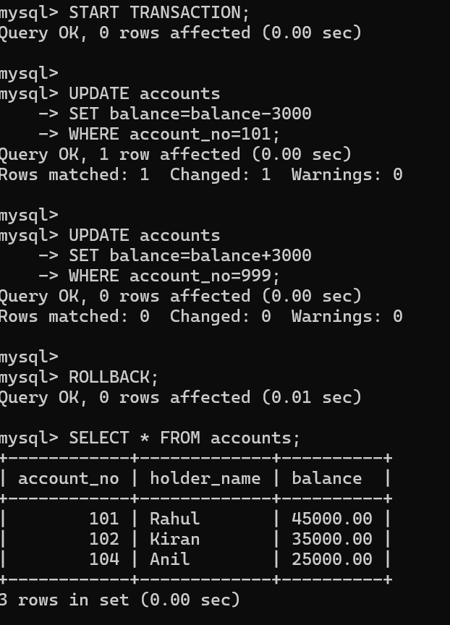

Q15. Demonstrate SAVEPOINT.
START TRANSACTION; UPDATE accounts SET balance=balance+2000 WHERE account_no=101; SAVEPOINT s1; UPDATE accounts SET balance=balance-1000 WHERE account_no=101; ROLLBACK TO s1; COMMIT;
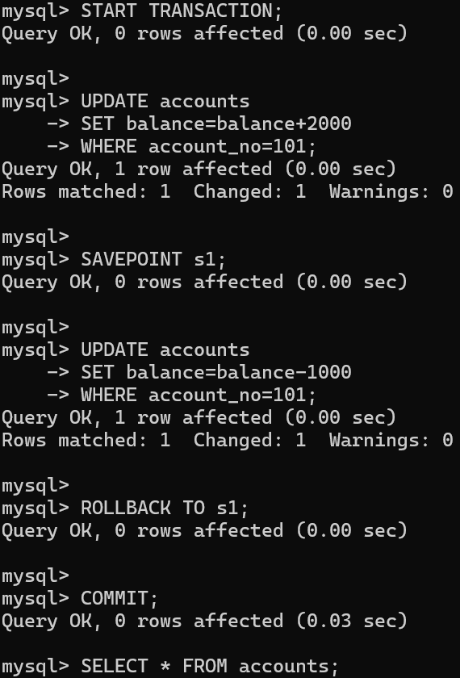
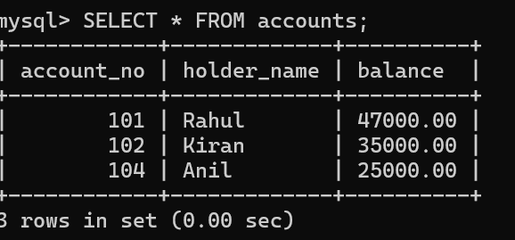
- Insert a new employee into the Employees table.
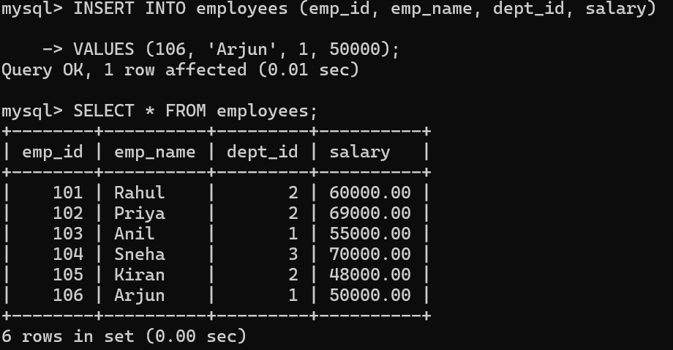
- Update the salary of employees working in the CSE department by 10%.
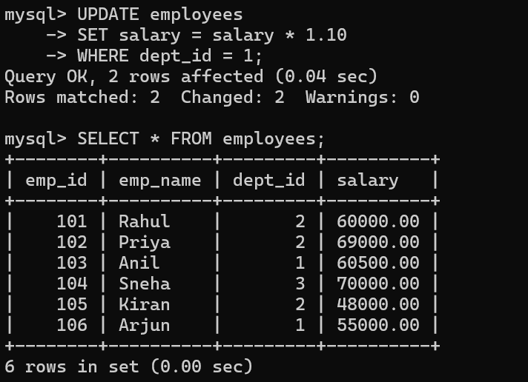
- Delete employees whose salary is below ₹30,000.
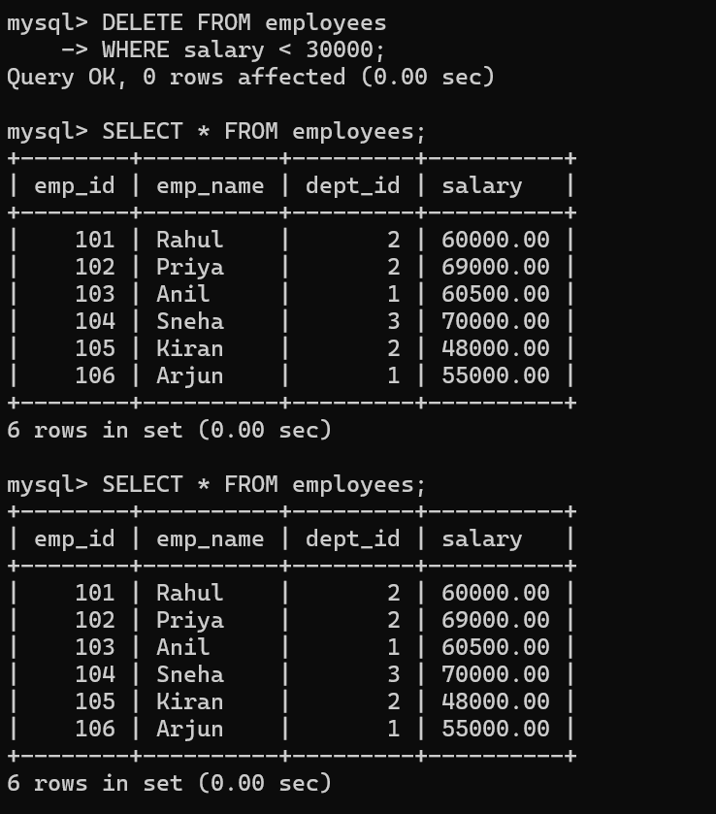

- Display all employee details.
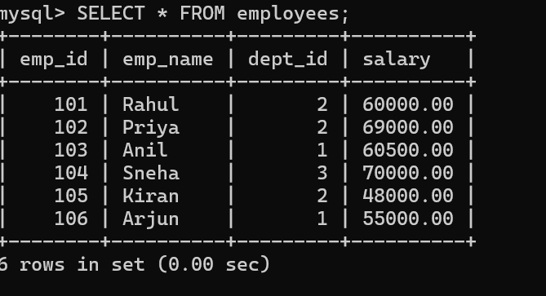
- Display employee names along with department names.
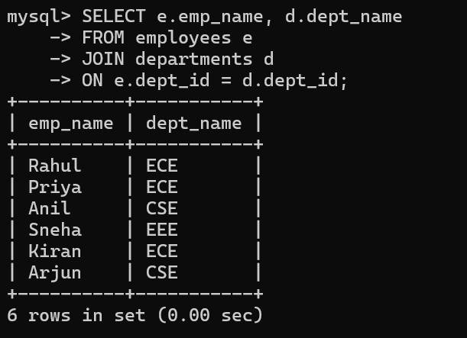
- Display employees who do not belong to any department.
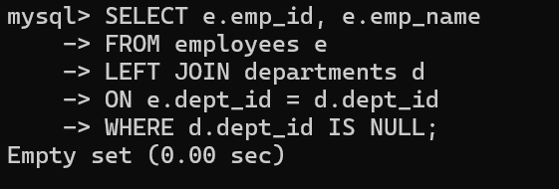
- Display all departments even if they have no employees.
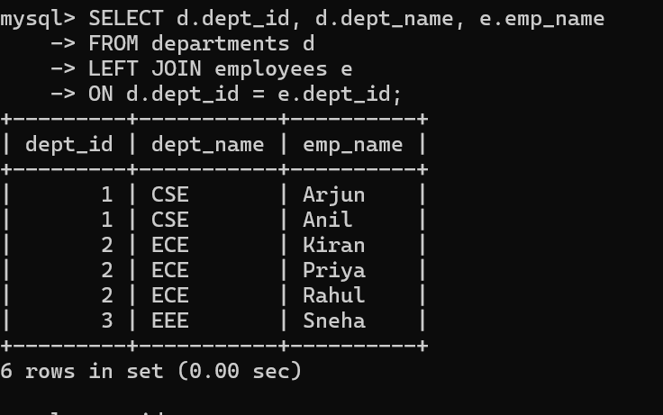
- Display employee and manager names using SELF JOIN.
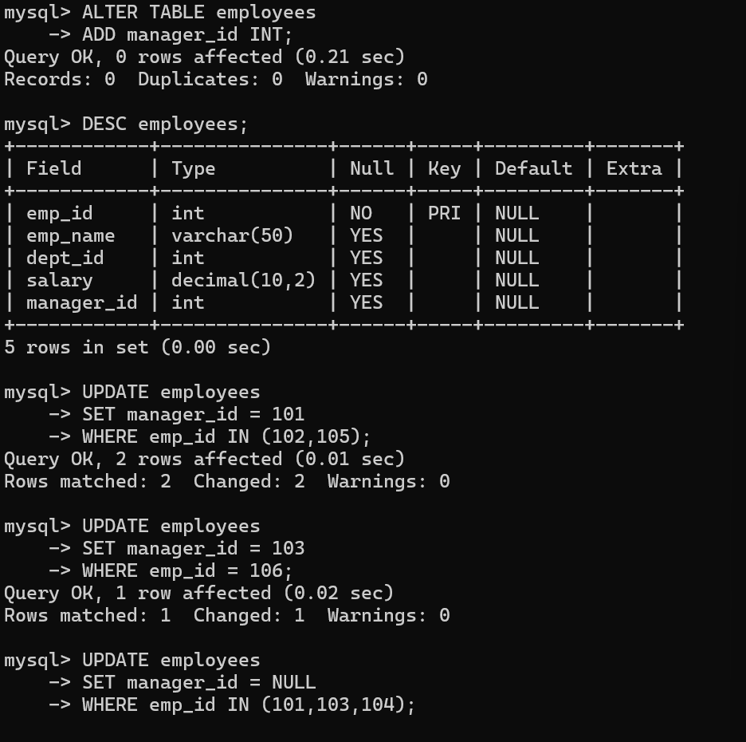
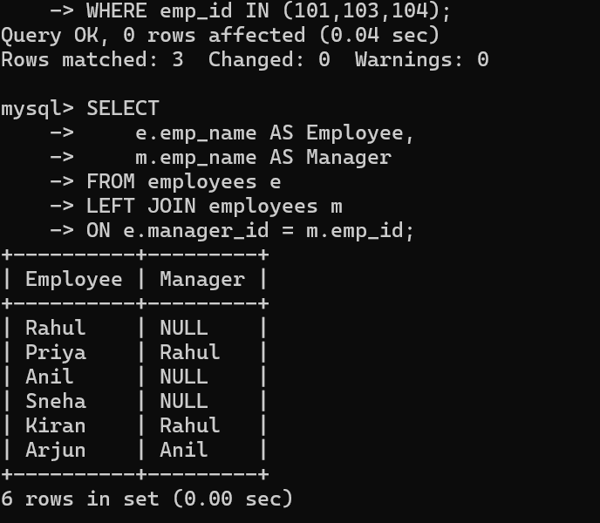
9.Find the total number of employees
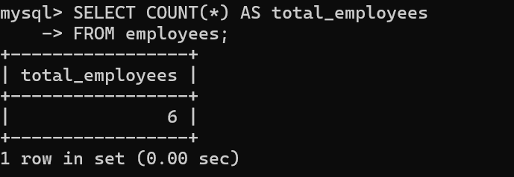
10.Find department-wise average salary.
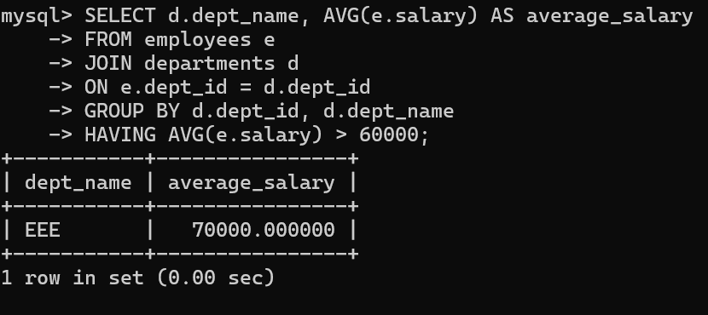
11. Display departments where average salary exceeds ₹60,000
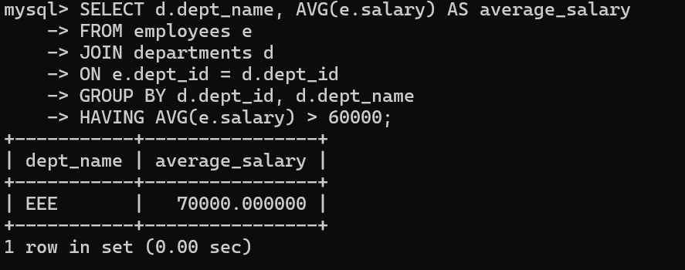
12.Display the highest and lowest salary.
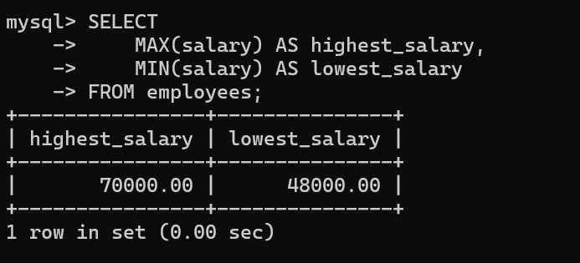
- Display employees earning more than the average salary
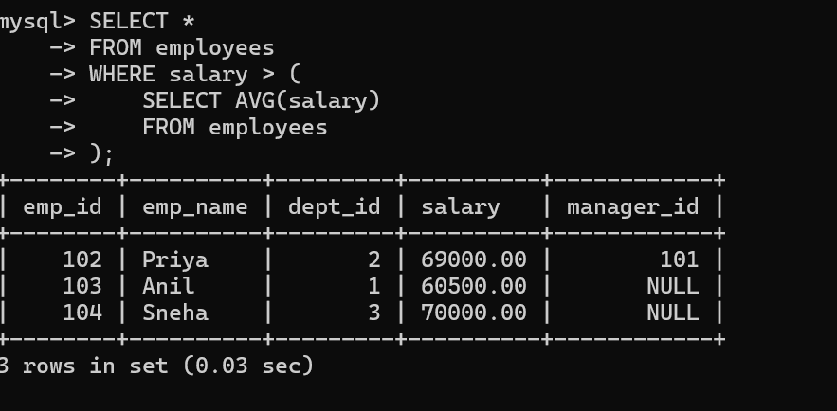
14.Find employees working in the same department as Rahul.
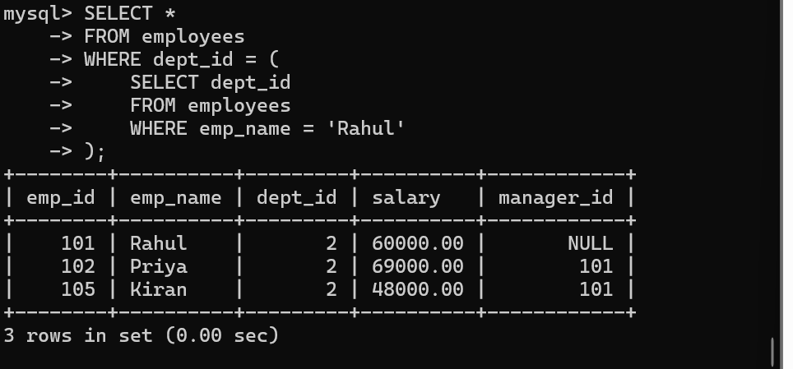
15.Display the employee receiving the highest salary
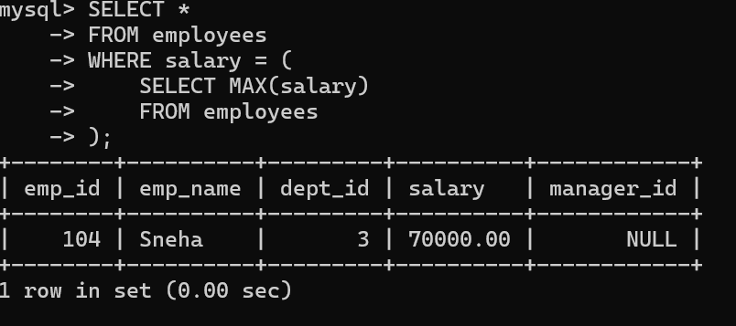
16.Display departments having more than five employees.
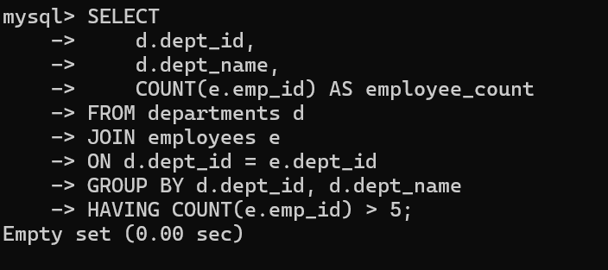
17.Find the second-highest salary using a window function
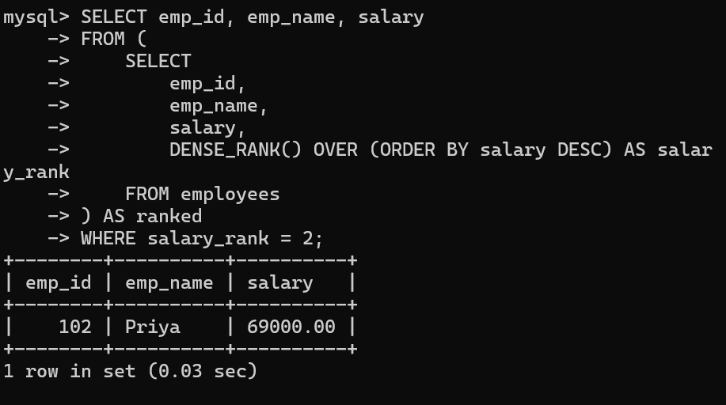
- Display employees earning above their department's average salary.
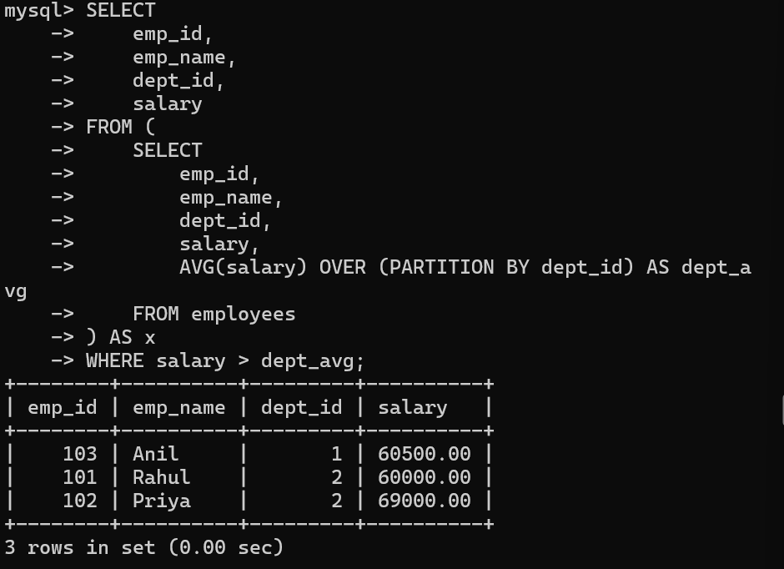
19.Find customers who have never placed an order.
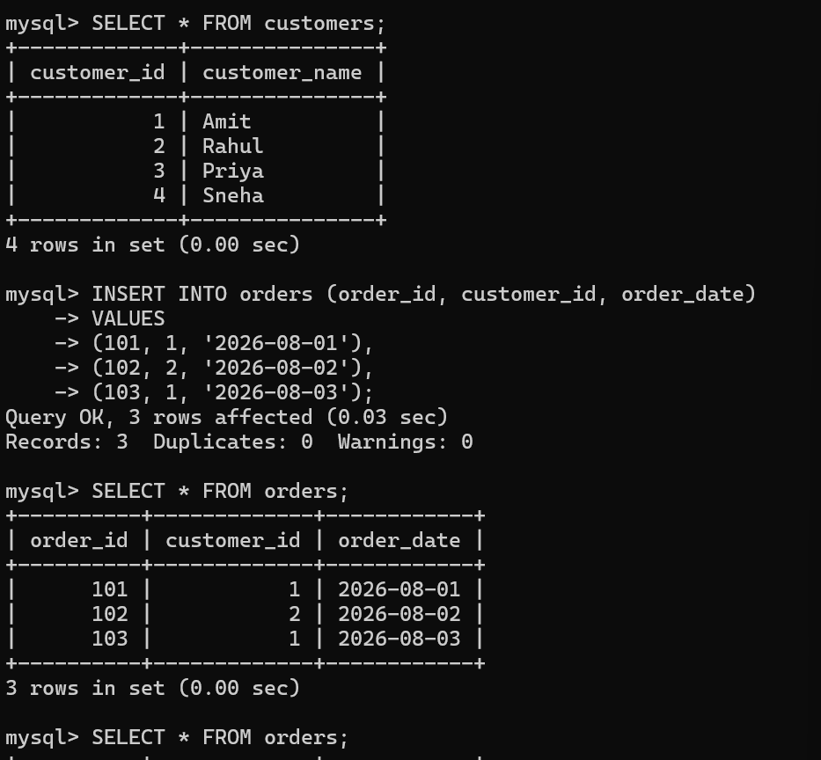
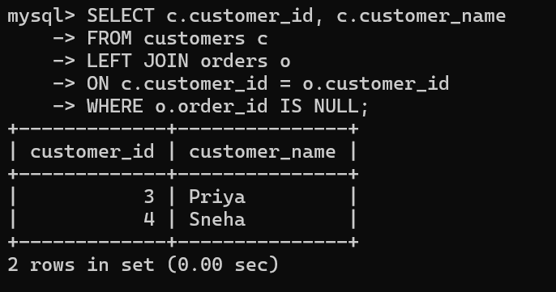
20.Display the top-selling product.
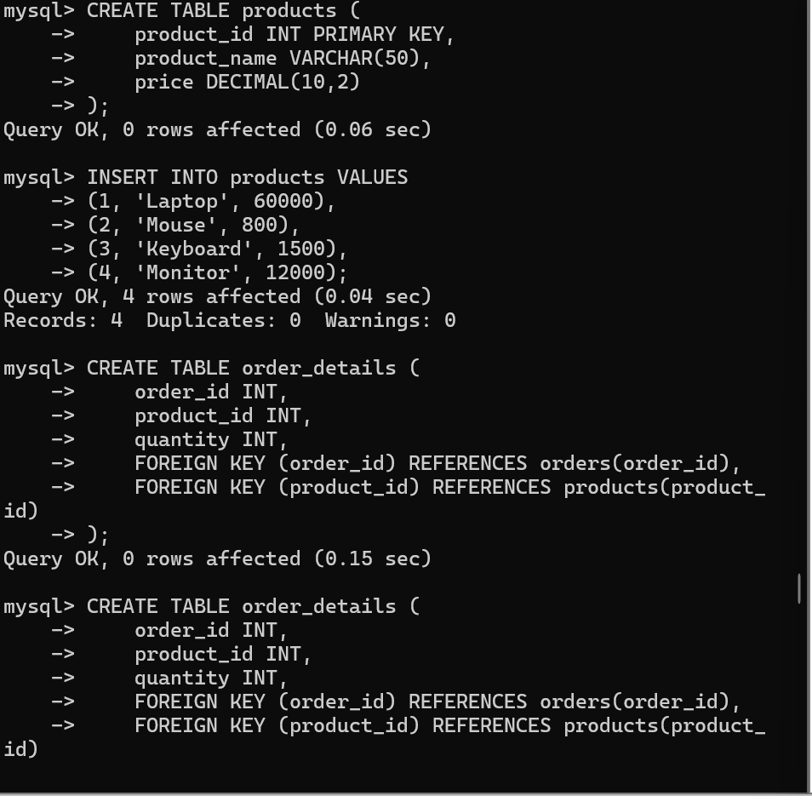
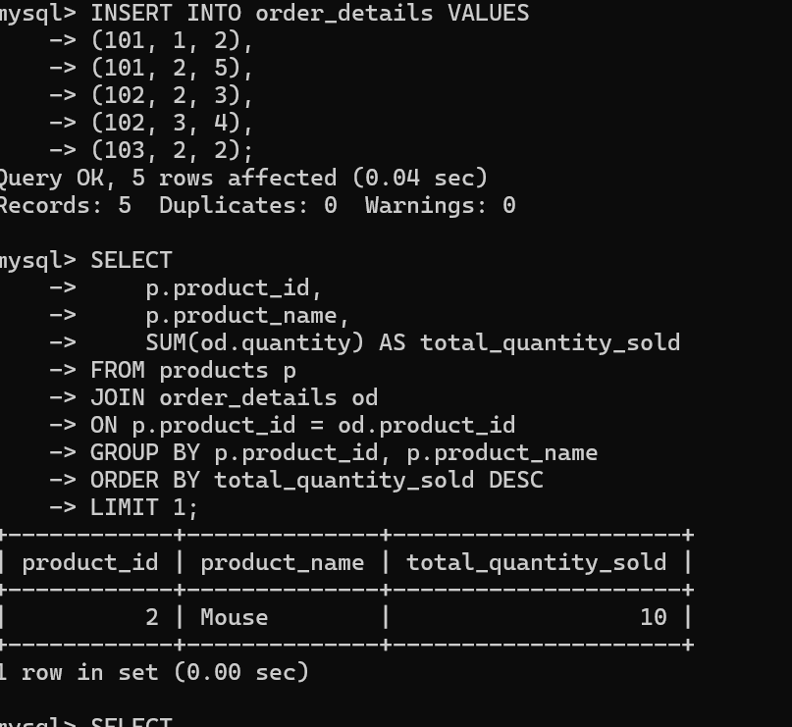
21.Find departments with the maximum number of employees.
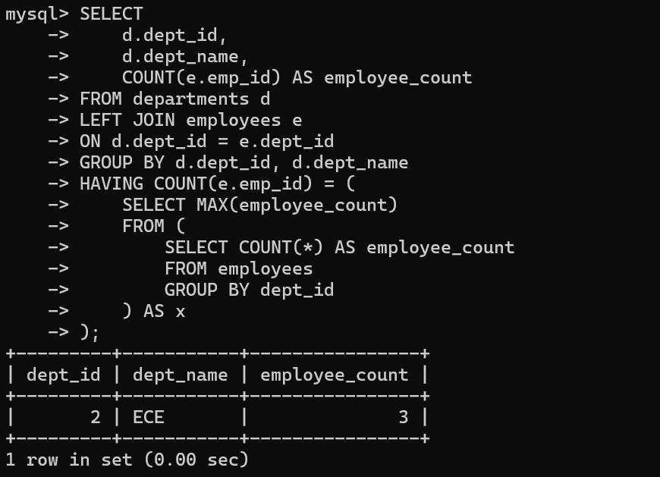
- Display monthly sales using window functions.
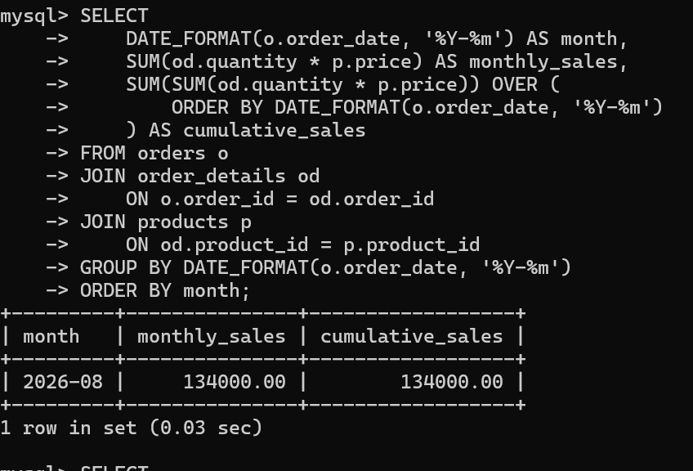
- Rank customers based on total purchase amount.
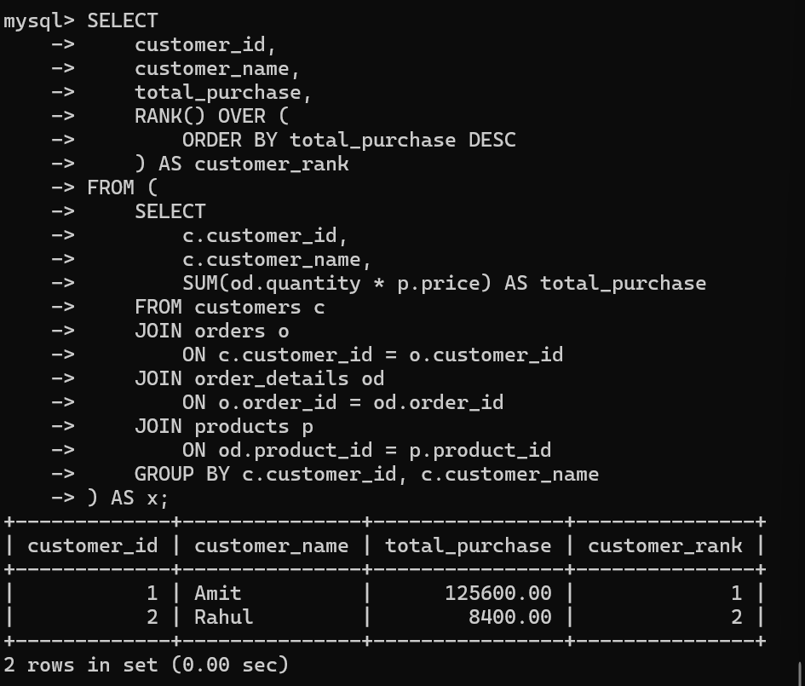
- Display employees whose salary is greater than their manager's salary.
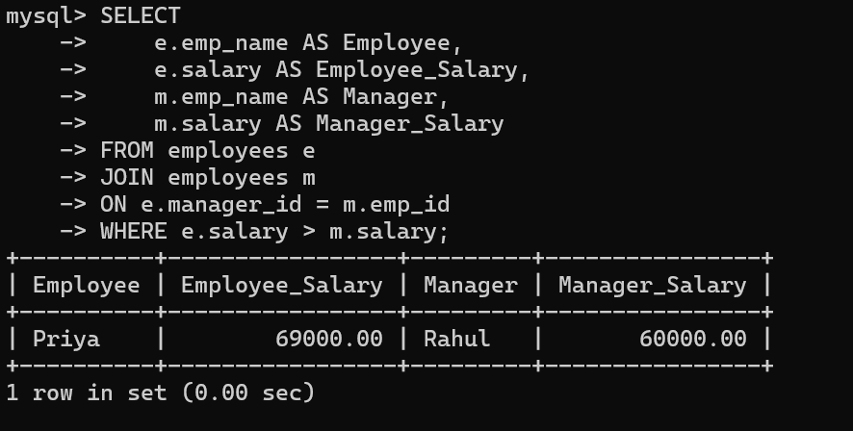
- Find duplicate email addresses using GROUP BY and HAVING.
